WEB PROGRAMMING

LAB ASSIGNMENT - 12

Student Name: Avyakth Shriram
Register Number: 24BCE5461
Course Slot: TG1
Course Faculty: Dr. Kanniga Devi

LAB 12 – TASK 1 – HTML:

<!DOCTYPE html>
<html>
<head>
<title>Checkbox</title>
<link rel="stylesheet" href="Task1.css" />
</head>
<body>
<h1 id="heading">Tell Me Your Favourite Subjects:</h1>
<div class="container">
<form >
<input name="subject" value="Maths" type="checkbox" checked/>Maths
<input name="subject" value="Science" type="checkbox"/>Science
<input name="subject" value="English" type="checkbox"/>English
<input name="subject" value="Social" type="checkbox"/> Social
<input name="subject" value="PT" type="checkbox"/> PT
</form>
<input type="button" onclick="success()" value="submit" id="btn"/>
<p id="para"></p>
</div>
<script type="text/javaScript" src="Task1.js"></script>
</body>
</html>

LAB 12 – TASK 1 – JavaScript:

const success = () => {
var subjects = document.querySelectorAll("input[name='subject']:checked");
let result = [];
for(let i = 0; i < subjects.length; i++) {
result.push(subjects[i].value);
}
document.getElementById("para").innerHTML = "Selected Subjects: " + result.join(", ");
}

LAB 12 – TASK 1 – CSS:

#heading {
color: rgb(255, 213, 0);
border: 2px solid black;
padding: 10px;
-webkit-text-stroke: 1px black;
}

body {
display: flex;
flex-direction: column;
justify-content: center;
align-items: center;
min-height: 100vh;
text-align: center;
background-color: lightgray;
margin: 0;
}

.container {
background-color: olive;
border: 3px solid black;
height: 400px;
width: 600px;
border-radius: 15px;
box-shadow: 10px 10px 25px rgba(0,0,0,0.4);
display: flex;
flex-direction: column;
justify-content: center;
align-items: center;
font-family: 'Gill Sans', 'Gill Sans MT', Calibri, sans-serif;
color: purple;
}

#btn {
border: none;
background-color: gray;
color: white;
margin: 20px;
padding: 10px 20px;
border-radius: 1rem;
cursor: pointer;
}

#btn:hover {
background-color: darkgray;
}

LAB 12 – TASK 1 – Screenshots:
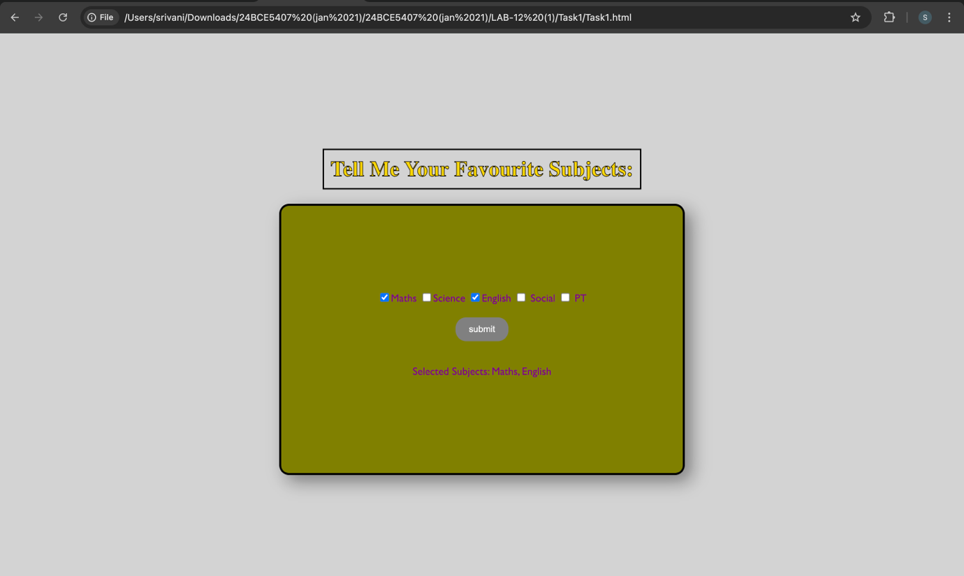

LAB 12 – TASK 2 – HTML:

<!DOCTYPE html>
<html>
<head>
<title>Unhide the hiddeen text</title>
<link rel="stylesheet" href="Task2.css" />
</head>
<body>
<form>
<input type="checkbox" name="hide-it" value="hide" />HIDE
</form>
<p id="para">You have accessed the Hidden content</p>
<input type="submit" onclick="success()" id="btn"/>
<script type="text/javaScript" src="Task2.js"></script>
</body>
</html>

LAB 12 – TASK 2 – JavaScript:

const success=()=>{
var hideCheckbox = document.querySelector("input[name='hide-it']");
if(hideCheckbox.checked){
document.getElementById("para").style.display = 'none';
} else{
document.getElementById('para').style.display = 'block';
}
}

LAB 12 – TASK 2 – CSS:

body {
font-family: Arial, sans-serif;
padding: 50px;
text-align: center;
background-color: #f0f2f5;
}

form {
margin-bottom: 20px;
}

#para {
font-weight: bold;
color: #2c3e50;
padding: 15px;
background: #fff;
border: 1px dashed #bdc3c7;
display: inline-block;
border-radius: 5px;
}

#btn {
display: block;
margin: 20px auto;
padding: 8px 20px;
cursor: pointer;
background-color: #3498db;
color: white;
border: none;
border-radius: 4px;
}

#btn:hover {
background-color: #2980b9;
}

LAB 12 – TASK 2 – Screenshots:

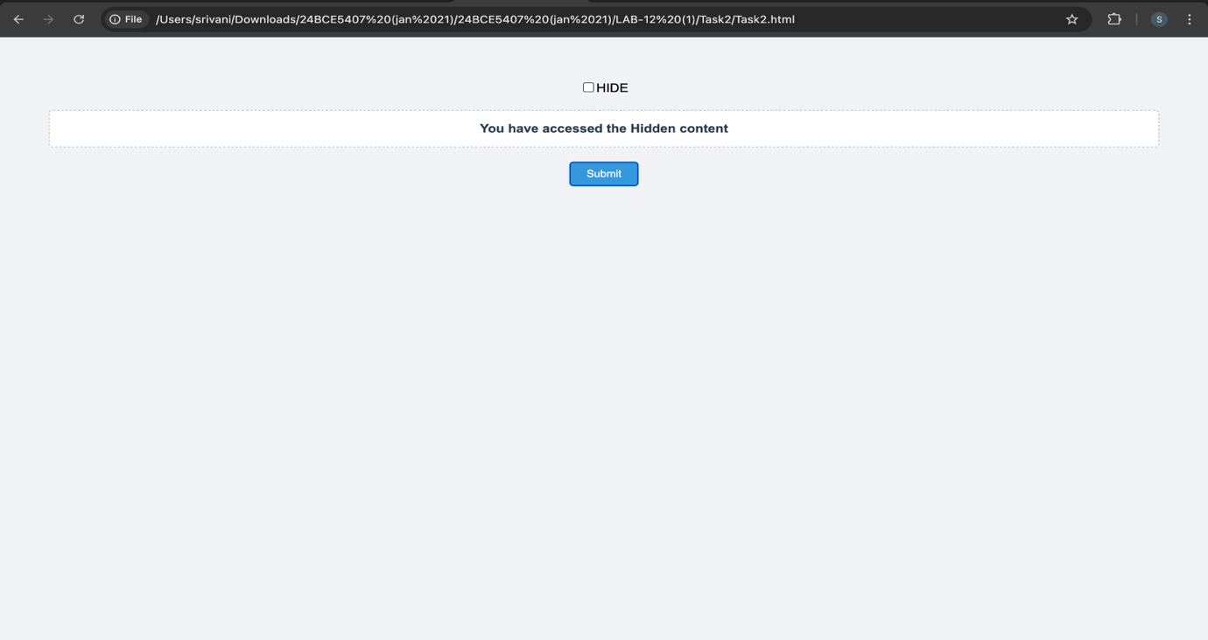

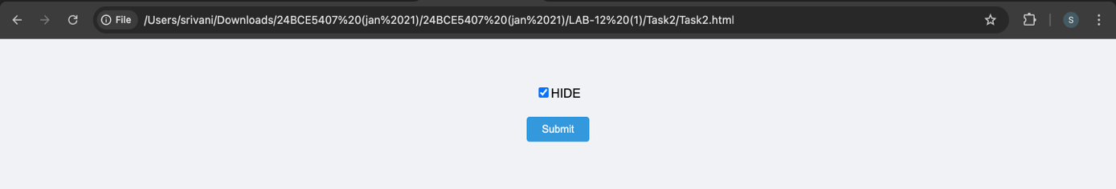

LAB 12 – TASK 3 – HTML:

<!DOCTYPE html>
<html>
<head>
<title>Display Price</title>
<link rel="stylesheet" href="Task3.css"/>
</head>
<body>
<h1 id="heading">Select the fruit</h1>
<form>
<select name="fruit" id="fruit-selection">
<option value="">--Choose--</option>
<option value="apple">Apple</option>
<option value="banana">Banana</option>
<option value="orange">Orange</option>
<option value="grapes">Grapes</option>
</select>
<p class="para"></p>
<input type="button" value="Submit" onclick="selectPrice()"/>
</form>
<script src="Task3.js"></script>
</body>
</html>

LAB 12 – TASK 3 – JavaScript:

function selectPrice() {
var dropdown = document.getElementById("fruit-selection");
var selectedFruit = dropdown.value;
var display = document.querySelector(".para");
if (selectedFruit === "apple") {
display.innerHTML = "Price of Apple is 100 Rs/kg";
} else if (selectedFruit === "banana") {
display.innerHTML = "Price of Banana is 50 Rs/kg";
} else if (selectedFruit === "orange") {
display.innerHTML = "Price of Orange is 70 Rs/kg";
} else if (selectedFruit === "grapes") {
display.innerHTML = "Price of Grapes is 120 Rs/kg";
} else {
display.innerHTML = "Please select a fruit.";
}
}

LAB 12 – TASK 3 – CSS:

body {
font-family: Arial, sans-serif;
display: flex;
flex-direction: column;
align-items: center;
justify-content: center;
height: 100vh;
margin: 0;
background-color: #f9f9f9;
}

#heading {
color: #333;
margin-bottom: 20px;
}

form {
background: white;
padding: 30px;
border-radius: 8px;
box-shadow: 0 2px 10px rgba(0,0,0,0.1);
text-align: center;
}

select {
padding: 10px;
font-size: 1rem;
border-radius: 4px;
border: 1px solid #ccc;
margin-bottom: 20px;
width: 200px;
}

input[type="button"] {
display: block;
width: 100%;
padding: 10px;
background-color: #28a745;
color: white;
border: none;
border-radius: 4px;
cursor: pointer;
font-size: 1rem;
}

input[type="button"]:hover {
background-color: #218838;
}

.para {
margin-top: 20px;
font-weight: bold;
color: #555;
min-height: 1.2em;
}

LAB 12 – TASK 3 – Screenshots:

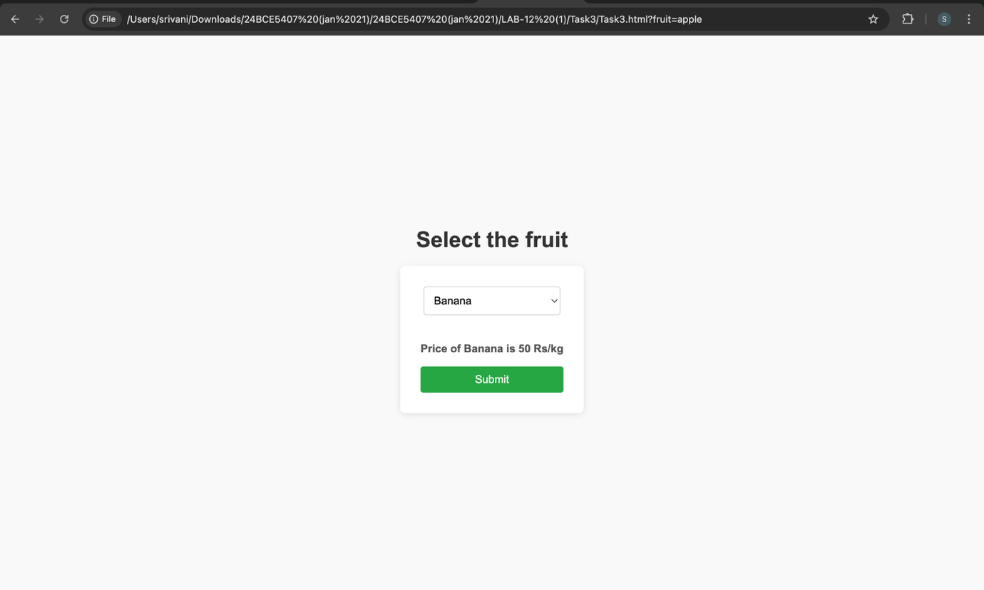

LAB 12 – TASK 4 – HTML:

<!DOCTYPE html>
<html>
<head>
<title>TEXTarea</title>
<link rel="stylesheet" href="Task4.css"/>
</head>
<body>
<form>
<textarea placeholder="type here" rows="5" cols="50" id="text-area">

</textarea>
</form>
<p class="para"></p>
<input type="submit" onclick="reverse()" value="reverse" id="btn"/>
<input type="submit" onclick="uppercase()" value="uppercase" id="btn"/>
<input type="submit" onclick="checklengreatthan10()" value="validate" id="btn"/>
<script src="Task4.js" type="text/javaScript"></script>
</body>
</html>

LAB 12 – TASK 4 – JavaScript:

function reverse(){
var textInput = document.getElementById("text-area").value;
var display = document.querySelector(".para");
var reversedText = textInput.split("").reverse().join("");
display.innerHTML = "Reversed Text: " + reversedText;
}
function checklengreatthan10(){
var textInput = document.getElementById("text-area").value;
var display = document.querySelector(".para");
if(textInput.trim().length <10){
display.innerHTML = "Error: Input must be at least 10 characters long.";
}else{
display.innerHTML = "Input is valid.";
}
}
function uppercase(){
var textInput = document.getElementById("text-area").value;
var display = document.querySelector(".para");
var uppercaseText = textInput.toUpperCase();
display.innerHTML = "Uppercase Text: " + uppercaseText;
}

LAB 12 – TASK 4 – CSS:

body {
font-family: sans-serif;
padding: 20px;
text-align: center;
}

textarea {
display: block;
margin: 10px auto;
padding: 10px;
border: 1px solid #ccc;
border-radius: 5px;
}

#btn {
padding: 10px 15px;
margin: 5px;
cursor: pointer;
background-color: #f0f0f0;
border: 1px solid #bbb;
border-radius: 3px;
}

#btn:hover {
background-color: #e0e0e0;
}

.para {
font-weight: bold;
color: #333;
margin-top: 15px;
}

LAB 12 – TASK 4 – Screenshots:

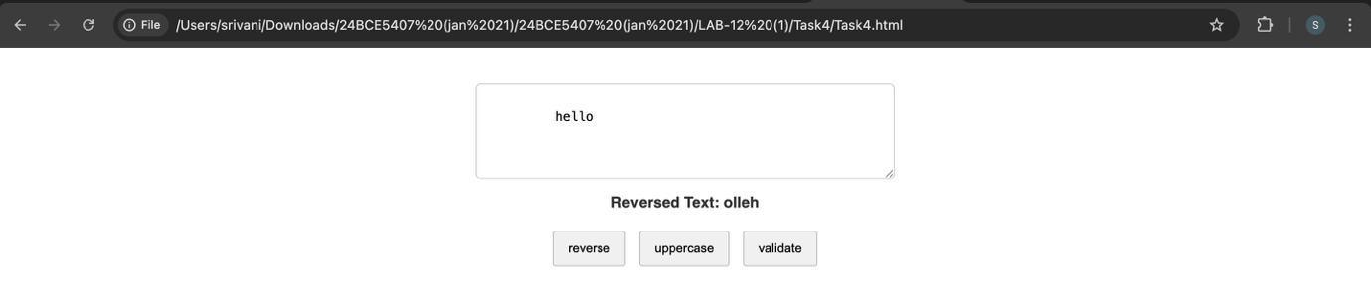
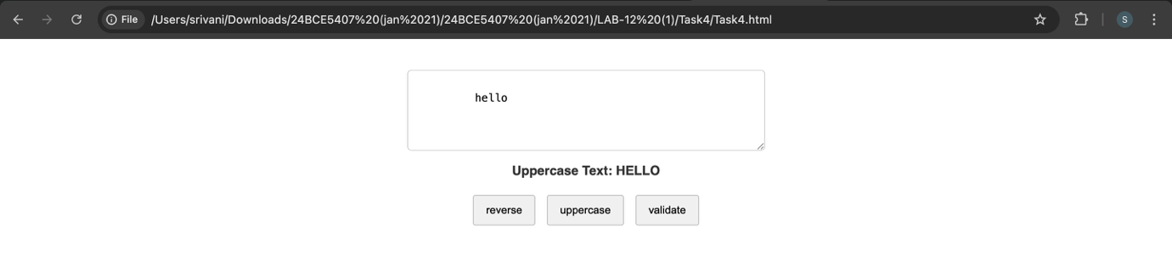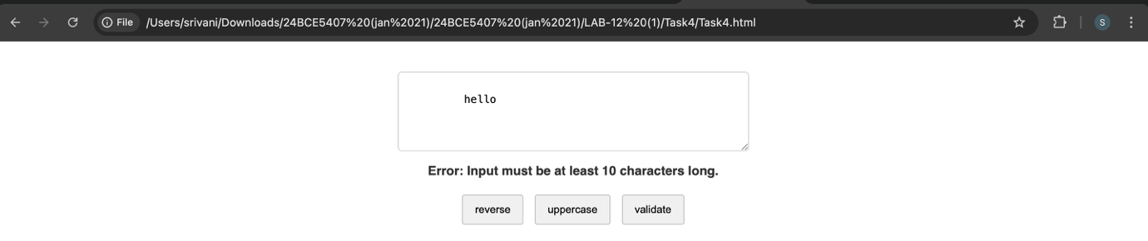

LAB 12 – TASK 5 – HTML:

<!DOCTYPE html>
<html>
<head>
<title>Display Price multiple</title>
<link rel="stylesheet" href="Task5.css"/>
</head>
<body>
<h1 id="heading">Select your fruits</h1>
<form>
<select name="fruit" id="fruit-selection" multiple>
<option value="apple">Apple</option>
<option value="banana">Banana</option>
<option value="orange">Orange</option>
<option value="grapes">Grapes</option>
</select>
<p id="result"></p>
<input type="button" value="Calculate Total" onclick="calculateTotal()"/>
</form>
<script src="Task5.js"></script>
</body>
</html>

LAB 12 – TASK 5 – JavaScript:

function calculateTotal() {
const selectedOptions = document.querySelectorAll('#fruit-selection option:checked');
const display = document.getElementById("result");

let total = 0;
let names = [];

const prices = {
apple: 100,
banana: 50,
orange: 70,
grapes: 120
};

selectedOptions.forEach(option => {
names.push(option.text.split(" -")[0]);
total += prices[option.value];
});

if (names.length > 0) {
display.innerHTML = "Selected: " + names.join(", ") + "<br>Total Price: " + total + " Rs";
} else {
display.innerHTML = "Please select at least one fruit.";
}
}

LAB 12 – TASK 5 – CSS:

body {
font-family: sans-serif;
text-align: center;
padding-top: 50px;
}

select {
width: 200px;
padding: 10px;
margin-bottom: 15px;
}

input {
display: block;
margin: 0 auto;
padding: 10px 20px;
cursor: pointer;
}

#result {
margin-top: 20px;
font-weight: bold;
color: green;
}

LAB 12 – TASK 5 – Screenshots:

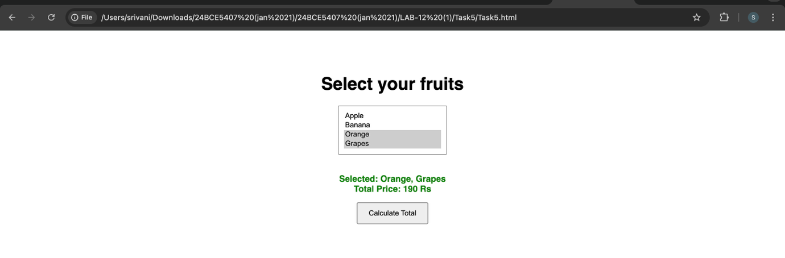

LAB 12 – TASK 6 – HTML:

<!DOCTYPE html>
<html>
<head>
<title>Hotel Pricing System</title>
<link rel="stylesheet" href="Task6.css">
</head>
<body>
<h1>Hotel Room Pricing System</h1>
<form id="pricingForm">
<fieldset>
<legend>Room Selection Details</legend>

<label for="month">Select Month:</label>
<select id="month">
<option value="january">January</option>
<option value="june">June</option>
<option value="july">July</option>
<option value="august">August</option>
<option value="december">December</option>
</select>
<br><br>

<label for="roomType">Select Room Type:</label>
<select id="roomType">
<option value="standard">Standard</option>
<option value="deluxe">Deluxe</option>
<option value="suite">Suite</option>
</select>
<br><br>

<input type="button" value="Check Price" onclick="findPrice()">
</fieldset>
</form>

<p id="output"></p>

<script src="Task6.js"></script>
</body>
</html>

LAB 12 – TASK 6 – JavaScript:

function findPrice() {
const month = document.getElementById("month").value;
const room = document.getElementById("roomType").value;
const output = document.getElementById("output");
let price = 0;
if (month === "june" || month === "july" || month === "august" || month === "december") {
if (room === "standard") price = 5000;
else if (room === "deluxe") price = 8000;
else if (room === "suite") price = 12000;
}
else {
if (room === "standard") price = 3000;
else if (room === "deluxe") price = 5000;
else if (room === "suite") price = 8000;
}
output.innerHTML = "The room price per day is: " + price + " Rs";
}

LAB 12 – TASK 6 – CSS:

body {
font-family: Arial, sans-serif;
padding: 20px;
}

fieldset {
background-color: #eeeeee;
border: 1px solid #ccc;
padding: 20px;
border-radius: 8px;
}

legend {
background-color: gray;
color: white;
padding: 5px 10px;
border-radius: 4px;
}

input[type="button"] {
margin-top: 10px;
cursor: pointer;
padding: 5px 15px;
}

#output {
margin-top: 20px;
font-weight: bold;
color: #2c3e50;
}

LAB 12 – TASK 6 – Screenshots:

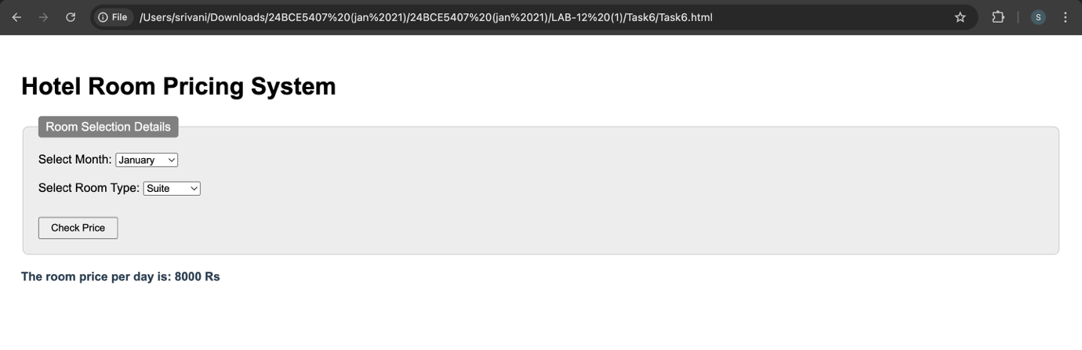

Thank you

